# 1.INTRODUCTION

* 1. Overview

1.This project is about having a plan to travel most of the places across the globe.

2.It will give some suggestions for your vacation plannings.

3.You can simply login to our "Discovery" app and then make use of it whenever and wherever

you want..

4.It will also show you the best choices for your vacation and also provide

you with the famous things across the globe.

* 1. Purpose

1. The main motto of this project is to make people get better of their choices in their level.

2.This application will show them the right way to go their vacation for better enjoyment..

3.Unauthenticated access can't be entered into this app forever...

Empathy Map

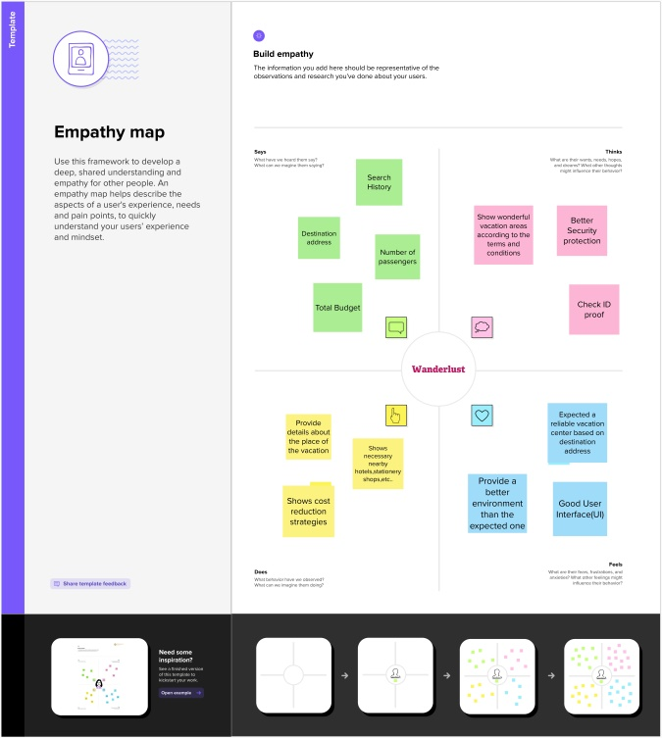

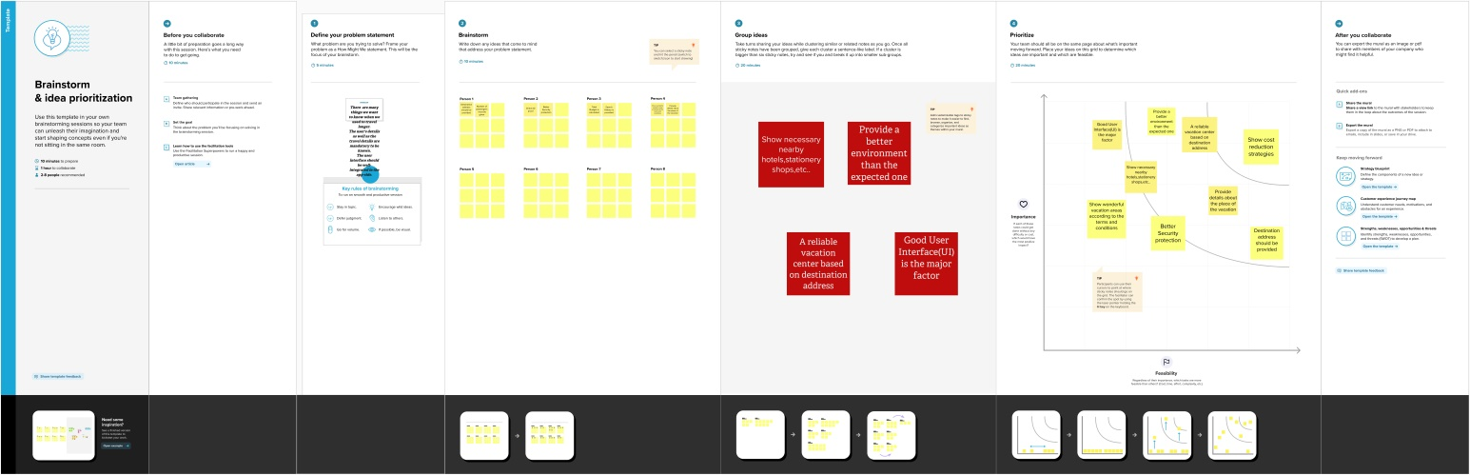Ideation & Brainstorming Map

# RESULT

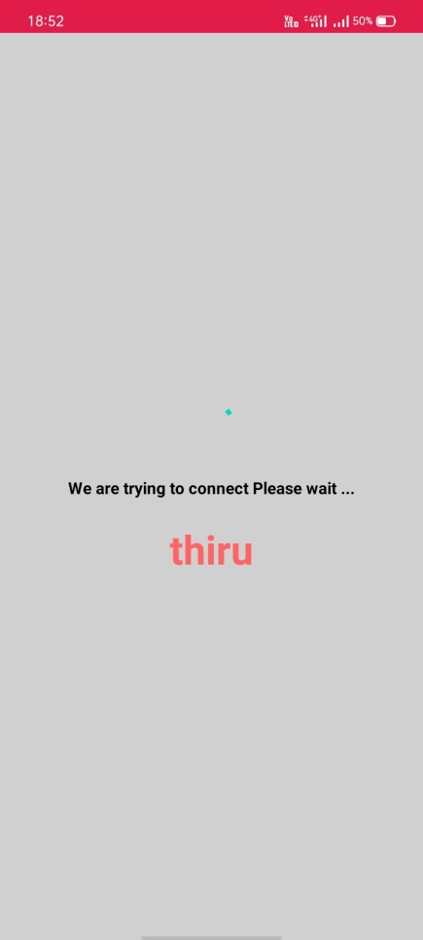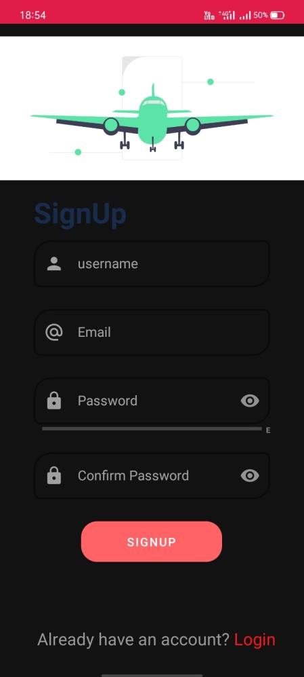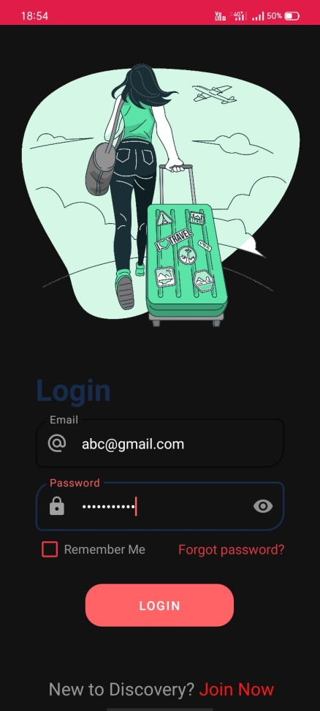

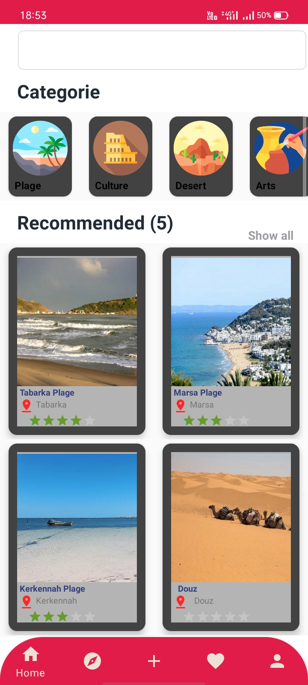

A

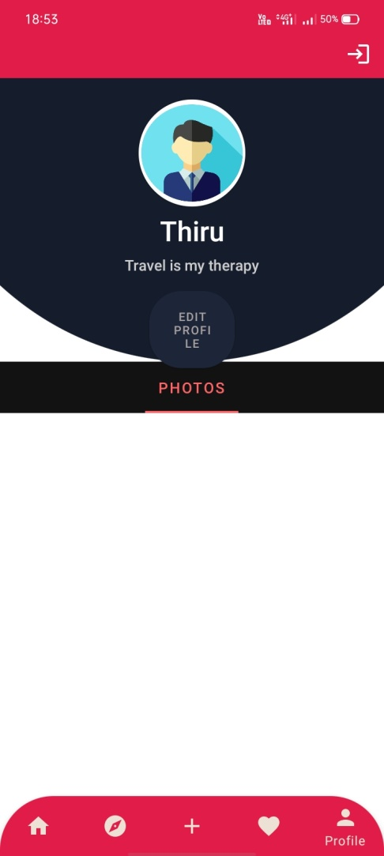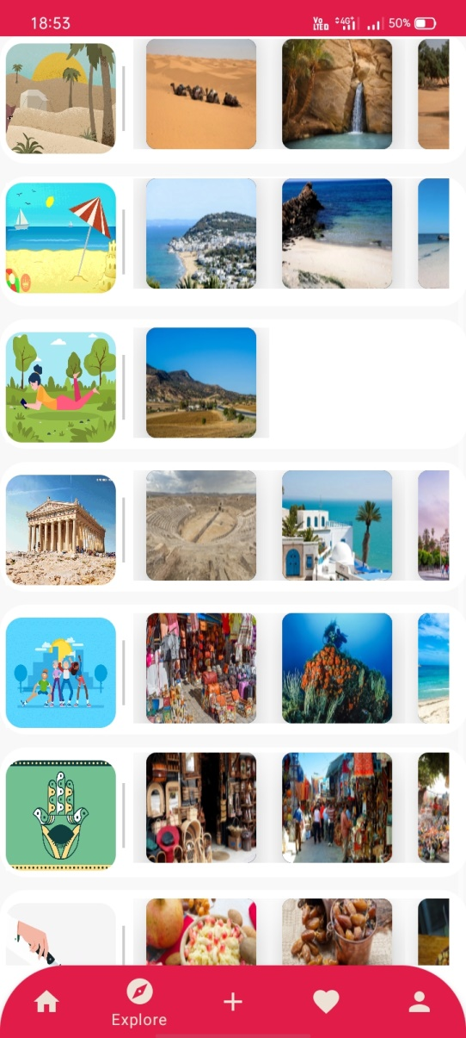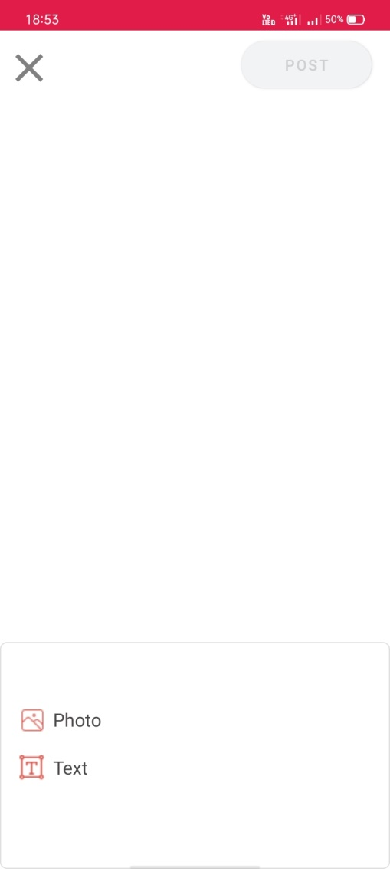

# 3.ADVANTAGES & DISADVANTAGES

# 

# ADVANTAGES:

# 1. The users can be able to get the best of their choices for their chosen vacation.

# 2. The application will provide all the necessary details according to the preferred location of the travelling place..

# 3. It will also provide the famous things in each and every cities with their respective pictures...

# 4. Better security protection

# DISADVANTAGES:

# 1. This application portrays only the important places and not others in the travel map..

# 2. One can't deduce cost in this application..

# 4.APPLICATIONS

# 1. This application can be used anywhere across the globe..

# 2. It is mainly used by the citizens who don't know to choose a good vacation arena..

# 3. This application is widely used in the countries which are in need of some travelling support..

# 4. It is essential for all the individuals who need to plan their trip for their weekends..

# 5.It is mostly used in all travelling stations for the user's successful journey

# throughout the world

# 5.CONCLUSION

# 1. This application is based on travelling app which showcasts some of the best tourist places around the globe.

# 2. The source code is written in Kotlin programming language..

# 3. The colors and other attributes are all provided in the source code itself..

# 4. Our application's name is "Discovery"..

# 5. There will be login page for all the registered and non-registered users.

# 6. For registered users, they can simply login to the page via their username and password.

# 7. For non-registered users , they need to sign up for their account and then log in..

# 8. Once entered , they can have the best travelling app in the world created by

# us..

# 6.FUTURE SCOPE

**1. Our application provides some of the important places across the globe .**

**This can be updated with the newly included places in the future..**

**2. Different layouts might be added for a good user interaction..**

**3. The places and cities might be added with their respected pictures to get a**

**grand response across the globe..**

**4. The user's search history can be added for their future use..**

**5. Automatic updating of the application might be provided via machine**

**learning and AI algorithms in the future..**

# 7.APPENDIX

# Source Code link:

# <https://github.com/thiru-mani-2002/Wanderlust-A-Personalized-Travel-Planning-and-Tracking-App>